Results
1. Experimental Design Overview
This project conducted multiple rounds of outdoor field deployments to compare the performance of a fixed-angle solar system and a single-axis solar tracking system. The experiments were carried out in London during the daylight saving period. All solar panels were installed facing south, with a tilt angle of 25°. The single-axis tracking system was capable of rotating from -90° (east) to +90° (west), approximating the sun's azimuthal movement from sunrise to sunset. Both the fixed and tracking systems used INA219 modules to collect real-time voltage and current data, which were transmitted to the TTN platform via LoRaWAN.

2. Analysis of Experimental Results
2.1 First Deployment (July 1–4)
- Setup: For each deployment, the tracking system required manual alignment to a = 0° (south) to allow the motor to determine its initial position for accurate tracking. Data were uploaded every 5 minutes during the day and every 30 minutes at night to conserve energy.
- Hardware Limitation: Due to gear mechanism constraints, the rotation angle was limited to ±72°.
- Data Types:
  - Fixed system: energy harvested by the solar panel, energy consumed by the logic circuit, and the corresponding average voltage and current values.
  - Tracking system: target angle, current angle, azimuth, two LDR values, energy harvested by the solar panel, energy consumed by the motor and logic circuit.
- Observations:
- The batteries were nearly fully charged prior to deployment, which led to almost no solar energy being harvested. The current approached zero, showing an open-circuit state (Table 1). This highlighted the necessity to upload raw voltage and current data in addition to cumulative energy metrics for accurate diagnosis.
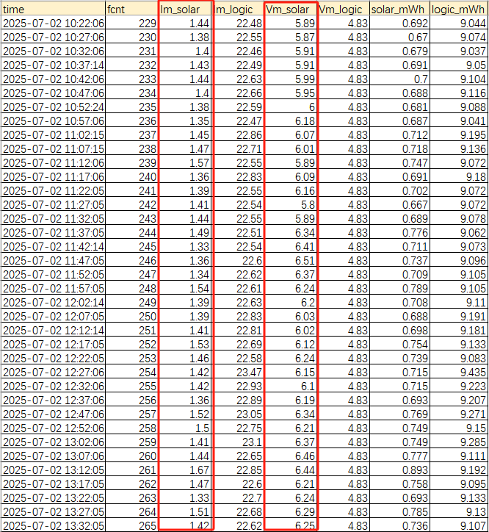
Table.1 Fixed device data on July 2
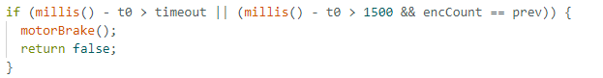
- The tracking system experienced operational instability. The motor sometimes stalled at a certain angle (Table 2) and ceased to follow the sun’s movement. Investigation revealed that the stall detection logic was overly aggressive (Figure 1), causing the motor driver to exit upon detecting minor resistance. The pursuit of energy efficiency compromised system stability.
Fig.1 The stall detection logic

Table.2 Single device data on July 2
- Data transmission was unreliable. Uploads were occasionally interrupted, and the system required manual rebooting, which is a critical flaw for remotely deployed outdoor devices. A LoRaWAN reconnection mechanism should be implemented to minimize data loss.
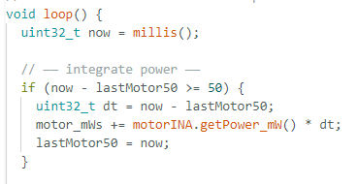
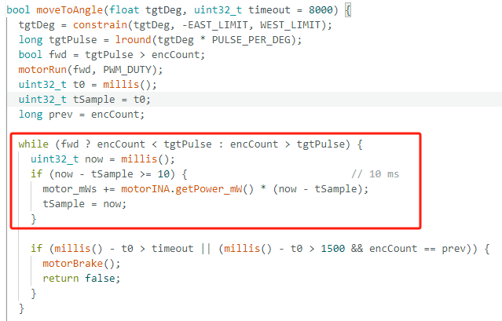
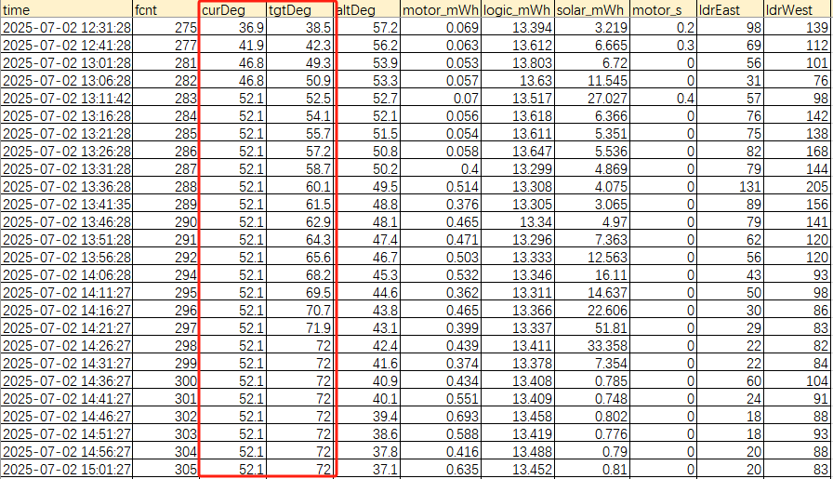
- Motor power consumption was inaccurately calculated. The system did not effectively distinguish between active and idle states, and duplicated sampling occurred both within the moveToAngle() function and the main loop (Figure2), leading to inflated power consumption statistics.
Fig.2 The moveToAngle() function and the main loop

2.2 Second Deployment (July 28–30)
- Optimizations:
- Integrated RTC module for automatic time synchronization.
- Improved mechanical design, expanding the rotation angle range to ±90°, and introduced auto-zeroing to -90° to ensure accurate positioning.
- Added LoRaWAN reconnection logic.
- Simplified motor control logic by removing the stall detection mechanism.
- Refined motor power computation by clearly separating active vs. idle sampling.
- Data Types:
  - Fixed system: energy harvested by the solar panel, energy consumed by the logic circuit, and the corresponding average voltage and current values.
  - Tracking system: target angle, current angle, azimuth, two LDR values, energy harvested by the solar panel, energy consumed by the motor and logic circuit, and corresponding average voltage and current values.
- Observations:
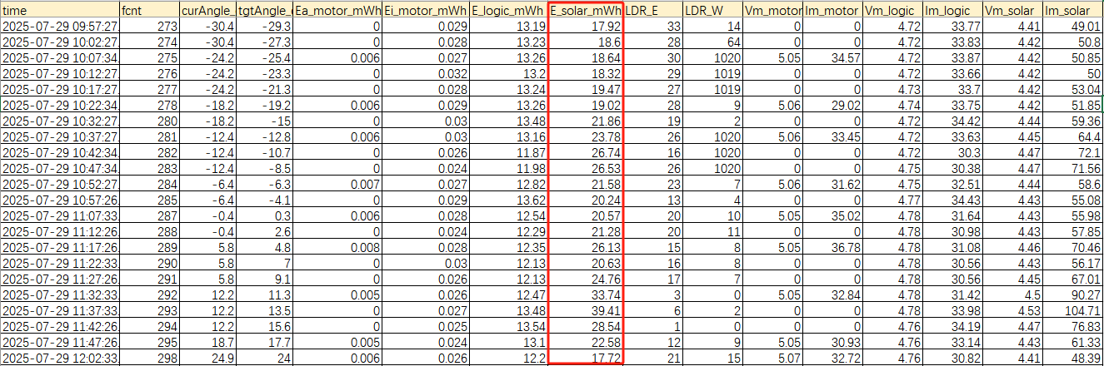
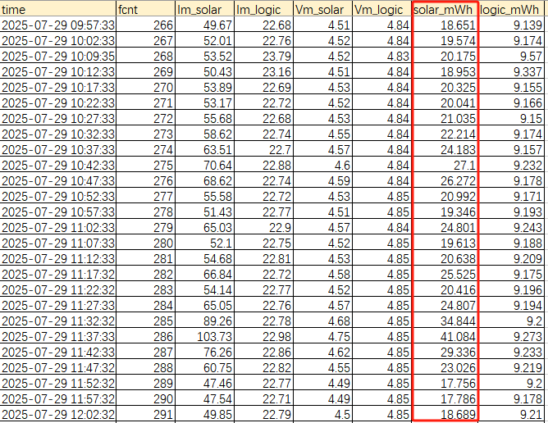
- Under cloudy conditions, the fixed panel outperformed the tracking system due to the predominance of diffuse and scattered light. Without a distinct solar direction, active tracking became meaningless, and if the panel rotated into a shadowed direction, energy absorption decreased (Table 3).
Table.3 Fixed device(down) and single device(up) data on July 29
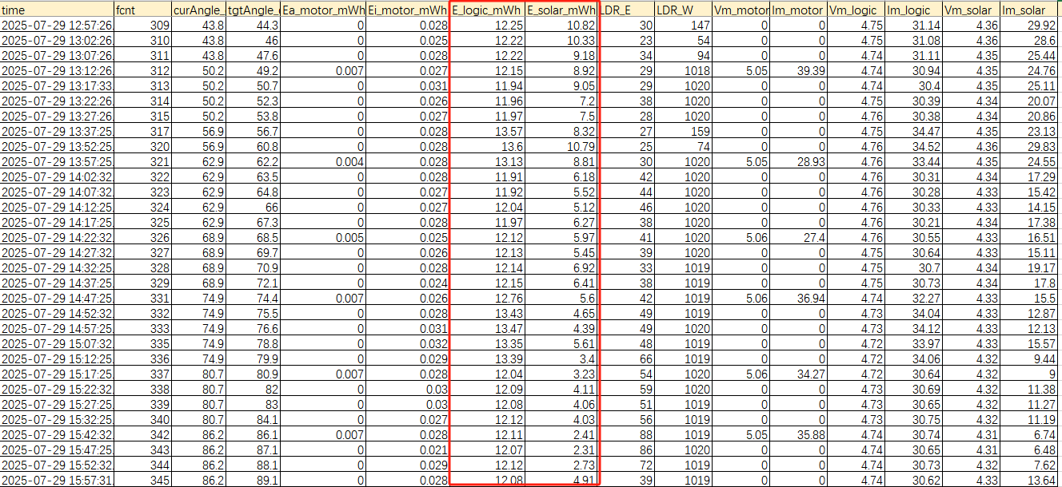
- The logic circuit’s power consumption was too high to be sustained by the energy harvested from the solar panel alone (Table 4). The MKR WAN 1310 board (SAMD21 MCU + LoRa module) consumed approximately 0.15W even in standby mode. Meanwhile, the small 1W solar panel (80×100mm) had an actual output of only 0.2–0.5W, leading to an energy deficit on cloudy days. Implementing a low-power sleep mode on the controller is necessary to extend system runtime.
Table.4 Sngle device data on July 29
- Angle mapping issues: The az-180 linear mapping algorithm caused truncation at sunrise and sunset, failing to cover the full solar trajectory (Table 5). In London summers, the solar azimuth span exceeds 180°, making the az-180 mapping inaccurate. A dynamic map() function is expected to perform better.
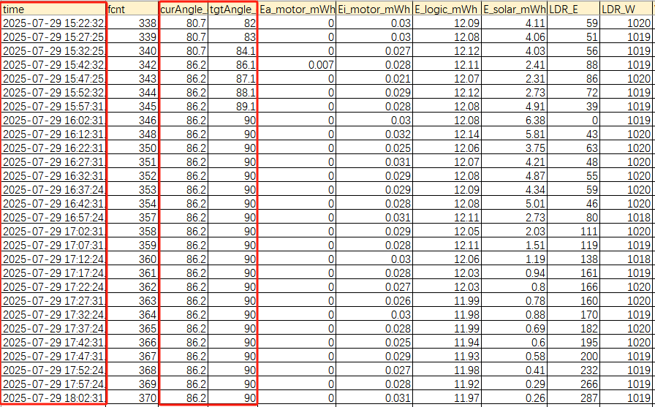
Table.5 Sngle device data on July 29

2.3 Third Deployment (Ongoing)
- Optimizations: Tracking mode is adjusted dynamically based on weather conditions.
- Sleep Mechanism: Deep sleep is activated to reduce power consumption during idle intervals.

Discussion
1. Design and Implementation Issues
1.1 Inadequate Solar Panel Output
The current 1W, 80×100mm solar panel is lightweight and easy to drive, but has a relatively low conversion efficiency (10–50%). It cannot maintain continuous system operation on cloudy days. Future iterations should consider high-efficiency monocrystalline panels with a minimum capacity of 3W.
1.2 Insufficient Energy Storage
Even under low-light conditions, a single 3.7V lithium-ion battery can quickly become fully charged, resulting in wasted solar energy. Adding supercapacitors in parallel would improve energy buffering and extend operation during prolonged overcast weather.
1.3 Eastward Return Strategy
Initially, a gravity-assisted passive return mechanism using water flow was considered to save energy at night. However, experimental results showed that motor-driven return requires minimal energy, offers higher precision, and avoids the need for complex mechanical structures and maintenance. This approach is more suitable for compact systems.

2. Deployment Challenges
2.1 Waterproofing
The 3D-printed PLA enclosure is biodegradable and inherently waterproof. However, gaps and screw holes in the casing allowed water ingress during rain, damaging internal components. This issue has been partially addressed by sealing all joints with adhesive and designing a sloped top cover. Future improvements could include the use of ABS/IP65-rated waterproof enclosures or waterproof coatings.
2.2 Site Limitations
The system was deployed on the rooftop garden at One Pool Street, where tall buildings cast shadows in the afternoon, significantly limiting solar energy capture. However, the advantage of a tracking system is most apparent during sunrise and sunset. Future deployments should be conducted in open areas with unobstructed exposure to the sun throughout the day.

